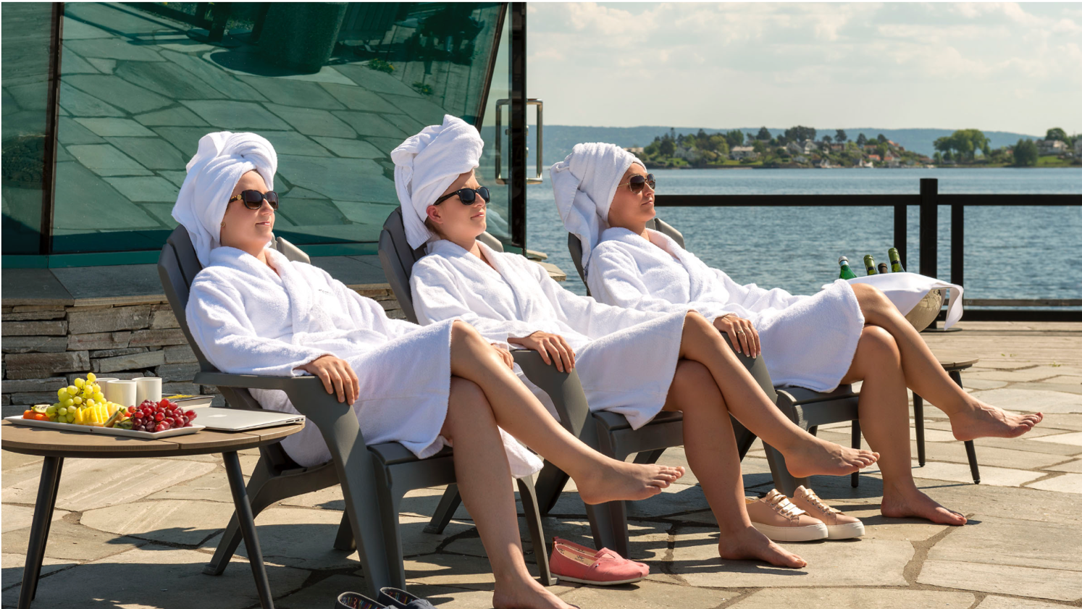
Lifestyle and wellness in the Greater Oslo Region
Suitable for: Individuals and groups

Contact: info@akershus.com
Phone: +47 907 72 715

For more details and inspiration visit our web site: www.visitgreateroslo.com

Follow us for more travel tips!
 @visitgreateroslo
 Visit Greater Oslo

Transport suggestions:
Charter bus: www.schaus.no www.viptransport.no
Rent a car: www.avis.no
Public transport - routing and fares: www.ruter.no
www.vy.no

Disclaimer: All requests are subject to availability and actual prices at the time of reservation.
Local pampering in Visit Greater Oslo!

Enjoy Scandinavian wellness, a fresh bath in the sea followed by a hot sauna, delicious local food or other adventures for mind and body. Some suggestions we recommend:

Spa and wellness:
- The Well Stay & Spa
- Son Spa and Hotel
- Holmen Fjordhotell Spa
- Rømskog Spa & Resort
- Lily country Club
- Hurdalsjøen Hotel & Spa

Local experiences for foodies:
- Ingierstrand Bad and Restaurant
- Tårnhuset Restaurant
- Vito’s Restaurant
- Hellviktangen Art Café
- Smakfulle Rom Restaurant
- Vertshuset Bærums Verk
- Local specialities from Smelters Mathus

Breweries:
- Aquavit distillery tour at Arcus
- Beer tasting at Vettre and Kringler Guest House



